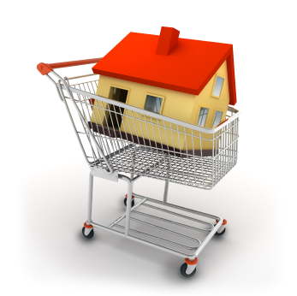
Purchasing a Property Assignment
Part A: What are you looking for?
- If you were to buy a home, what sort of features would you look for? Make a list of at least 10 features that you would want your house to have. For example, do you want a garage, a fireplace, a pool, a big kitchen, more than one bathroom? Anything like that would be considered a feature

- Think about where you would like your house to be located.
a) What town/city would you like to live in? _______________________ or would you rather be in the country?
b) Name a few places you would like to have close by, such as a grocery store, mall, parents, work, school (list two that are most important to you)
________________________________ ________________________________

Part B: Pre-Approval
Using your anticipated annual income, how much mortgage would you be pre-approved for?
(use the CMHC affordability calculator at https://www.cmhc-schl.gc.ca/en/finance-and-investing/mortgage-loan-insurance/homebuying-calculators/affordability-calculator or a financial institution mortgage pre-approval calculator)
Anticipated Career & Annual Income:
Mortgage Company:
Mortgage Type & Term:
Mortgage Rate:
Maximum Mortgage:
Maximum House Price:
Maximum Monthly Mortgage Payment:
CMHC Mortgage Loan Insurance Premium:
Part C: Go Shopping!
Please go to the website www.realtor.ca.
- Enter your city and any other features you would like, then hit GO.
- A map should appear with little blue dots of properties available for sale. Look through the areas and when you find one you like, you may click on it to see all of its features.
- Try to find a home that has the features you wanted, is in the right location and is within your price range.
Home Type: (Condo, Single Detached, Duplex)
Selling Price:
Address:
Town/City/Neighborhood:
# of Bedrooms:
# of Bathrooms:
Other:
Part D: The Mortgage
Use the CMHC or a financial institution calculator to determine your payments. Assume a 25 year amortization period: https://www.cmhc-schl.gc.ca/en/finance-and-investing/mortgage-loan-insurance/homebuying-calculators/mortgage-calculator
Down Payment Minimum Amount (5%):
Down Payment of 20%:
Actual Mortgage Amount (selling price – down payment):
Payment Frequency:
Interest Rate:
How much interest will you pay in the first year?
How much principal will you pay off in the first year?
How much interest will you pay in the 25th year?
How much principal will you pay off in the 25th year?
How much interest will you pay over the entire 25 year amortization?
What is the total cost of the house?
Mortgage interest rates can change sometimes suddenly, like in the 1980s. What would be your new monthly payment if interest rates all of a sudden shot up to 13%?

Part E: Other Housing Expenses
- Other than the mortgage payment, there are a lot of other expenses that come with owning a home. Try to make a list of at least 10 other expenses (think of bills, repairs, taxes)

- Each city has its own rate for property taxes. Assuming your house is in Regina, and the rate is 1.14% of the value of your home (use the cost before you took off the down payment).
Use the City of Regina website to find out more about Property Taxes: https://www.regina.ca/home-property/residential-property-tax/property-tax/index.html

a) How much would you pay in property taxes each year?

Part F: Tips on Purchasing a Home
- Make a list of at least six tips you would give someone who is about to purchase a home. (Think of things like, cost, location….)

Based on your research, would you prefer to rent or purchase property? Would you live alone or with roommates? Any other factors that need to be considered or questions to answer?

